Multiple-choice section

|  |  |  |  |  |  |  |  |  |
| --- | --- | --- | --- | --- | --- | --- | --- | --- |
| Question | 1 | 2 | 3 | 4 | 5 | 6 | 7 | 8 |
| Answer | C | C | A | B | A | B | D | C |

Question 1 [9.1]

C

3 + 9 + 2 + 6 = 20

Black:  × 2500 = 375

Orange: 375 × 2 = 750

Question 2 [9.1]

C

Population size =  × 500 = 3750

Question 3 [9.2]

A

The mode is the score that occurs most frequently.

Question 4 [9.5]

B

The list of all possible outcomes is called the sample space.

Question 5 [9.6]

A

There are 13 diamonds and 52 cards altogether in a standard pack of playing cards.

Probability of drawing a diamond:

= 

Question 6 [9.7]

B

In a Venn diagram, the notation used to represent the complement of *A* is *A*'.

Question 7 [9.5]

D

There are 20 numbers altogether and 6 of them are divisible by 3 (i.e. 3, 6, 9, 12, 15, 18).

Probability of drawing a number that is divisible by 3 is .

Question 8 [9.4]

C

Class centre = 

Multiple-choice total marks: 8

Short answer section

Question 9 2 marks [9.7]

(a) A *Venn diagram* can be used to work out the probability of an event occurring.

(b) The *union* of *A* and *B* includes the outcomes that are in *A* or *B* (or both).

Question 10 2 marks [9.1]

A population is the entire number of objects in a category. It often refers to people, but in statistics it is used to describe any defined category, such as birds, insects, light globes, vases, cars.

Question 11 2 marks [9.1]

Example 3 is a convenience sample because the nurses are in one place, so it is easy to see all of them at one time. It is also a judgement sample as people dealing with injuries have evidence to support their views.

Bias is very likely as, even though the group’s opinions may be valid, it doesn’t mean they reflect opinions held generally in the community.

Question 12 3 marks [9.6]

(a) 1 – (0.12 + 0.26 + 0.31 + 0.08 + 0.04 +0.02) = 0.17

|  |  |
| --- | --- |
| Children in the family | Probability |
| 0 | 0.12 |
| 1 | 0.26 |
| 2 | 0.31 |
| 3 | 0.17 |
| 4 | 0.08 |
| 5 | 0.04 |
| > 5 | 0.02 |

(b) (i) Pr(1 or 2)= 0.26 + 0.31 = 0.57  
0.57 × 850 = 484.5  
485 families

(ii) Pr(3 or more) = 0.17 + 0.08 + 0.04 + 0.02 = 0.31   
0.31 × 850 = 263.5  
264 families

Question 13 9 marks [9.4]

(a)

|  |  |  |
| --- | --- | --- |
| *x* | *f* | *x × f* |
| 42  43  44  45  46 | 9  12  7  1  1 | 378  516  308  45  46 |
| Total | 30 | 1293 |

mean =  = 43.1

median is 15th/16th position: 43

mode: *f* = 12 ↔ *x* = 43

range = 46 – 42 = 4

(b) mean =  = 42.5 (lower by 0.6)  
median is 15th/16th position: 43 (no change)  
mode: *f* = 12 ↔ *x* = 14 (no change)  
range = 46 – 40 = 6 (higher by 2)  
The mean and range were changed but the median and mode were unaffected.

Question 14 6 marks [9.3]

(a)

|  |  |
| --- | --- |
| Result | Frequency |
| 1–5  6–10  11–15  16–20  21–25 | 5  5  6  6  8 |

(b)

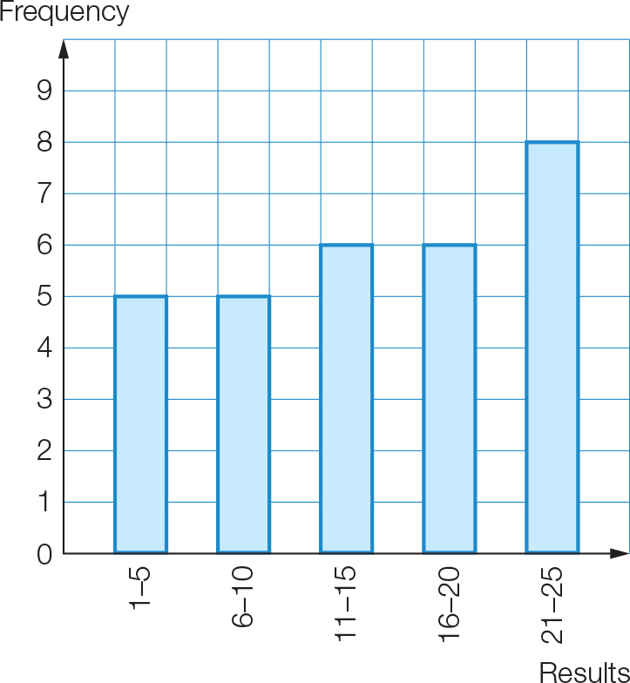

Question 15 5 marks [9.4]

(a) (i) There are 20 data values. The median is between the 10th and 11th values.  
median = (153 + 156) ÷ 2 = 154.5

(ii)

= 153

(b)

|  |  |  |  |
| --- | --- | --- | --- |
| Class | Midpoint  *x* | *f* | *x* × *f* |
| 130–139  140–149  150–159  160–169  170–179 | 134.5  144.5  154.5  164.5  174.5 | 4  5  4  6  1 | 538  722.5  618  987  174.5 |
| Total | | 20 | 3040 |



The estimate is very close to the actual mean.

Question 16 2 marks [9.5]

(a) Pr(not 3 or 5) =  = 

(b) Greater than 2, i.e. 3, 4, 5, 6, 7, 8, 9, 10

Question 17 3 marks [9.6]

(a) Pr(M) = 

(b) Pr(consonant) = 

(c) Pr(T, E, A, M) = 

Question 18 4 marks [9.6]

(a) Pr(Jack or hearts) =  =  = 

(b) Pr(Jack of hearts) = 

(c) Pr(Jack or hearts but not both) =  = 

Question 19 3 marks [9.7]

Total number of students = 2 + 20 + 10 + 8 = 40

(a) Total number of students who play the guitar: 10 + 8 = 18  
Pr(*G*) =  = 

(b) Pr(*P* or *G*) =  =  = 

(c) Pr(*P* and *G*) =  = 

Question 20 3 marks [9.7]

(a) *n*(ξ) = 5 + 18 + 3 + 4 = 30

(b) *n*(*M* or *F*) = 18 + 3 + 4 = 25  
Pr(*M* or *F*) =  = 

(c) Pr(*F* ') =  = 

Question 21 4 marks [9.7]

(a)

|  |  |  |  |
| --- | --- | --- | --- |
|  | Fish | No fish |  |
| Rabbit | 14 | 10 | 24 |
| No rabbit | 4 | 2 | 6 |
|  | 18 | 12 | 30 |

(b) Pr(rabbit and fish) =  = 

Short answer total marks: 48

Extended answer section

Question 22 9 marks [9.3, 9.4, 9.5]

(a)

|  |  |  |  |
| --- | --- | --- | --- |
| Class interval | *x* | Frequency (*f*) | *xf* |
| 25–<30 | 27.5 | 7 | 192.5 |
| 30–<35 | 32.5 | 9 | 292.5 |
| 35–<40 | 37.5 | 11 | 412.5 |
| 40–<45 | 42.5 | 14 | 595 |
| 45–<50 | 47.5 | 16 | 760 |
| 50–<55 | 52.5 | 19 | 997.5 |
| 55–<60 | 57.5 | 14 | 805 |
|  |  | Σ*f* = 90 | Σ*fx* = 4055 |

(b) Horizontal axis: 25, 30, 35, 40, 45, 50, 55, 60

(c) (i) estimated mean =  = = 45.1 (correct to 1 d.p.)

(ii) modal class interval: *f* = 19 ↔ 50–<55

(iii) Both the 45th and 46th values are in the 45–<50 class interval.

Median class interval is 45–<50

(d) Pr(< 45) =  =  ≈ 46%

Question 23 10 marks [9.1]

(a) (i) Set A: 2, 4, 9, 11, 4, 6, 2, 6, 2, 3. Mean =  = 4.9 letters per word  
Set B: 3, 6, 10, 5, 2, 3, 4, 3, 4, 3. Mean =  = 4.3 letters per word  
Set C: 2, 4, 11, 6, 2, 4, 2, 4, 3, 2. Mean =  = 4 letters per word  
Set D: 2, 4, 3, 3, 4, 2, 7, 3, 4, 3. Mean =  = 3.5 letters per word  
Set E: 4, 5, 2, 6, 3, 3, 2, 2, 9, 2. Mean =  = 3.8 letters per word  
Set F: 2, 4, 3, 3, 2, 4, 4, 1, 3, 7. Mean =  = 3.3 letters per word

(ii) Set A: Proportion with an ‘i’ =  = 0.2  
Set B: Proportion with an ‘i’=  = 0.3  
Set C: Proportion with an ‘i’=  = 0.1  
Set D: Proportion with an ‘i’=  = 0.2  
Set E: Proportion with an ‘i’=  = 0.2  
Set F: Proportion with an ‘i’=  = 0

(b) (i) Combined set A with B: Mean =  = 4.6 letters per word  
Combined set C with D: Mean =  = 3.75 letters per word  
Combined set E with F: Mean =  = 3.55 letters per word

(ii) Combined set A with B: Proportion with an ‘i’ =  = 0.25  
Combined set C with D: Proportion with an ‘i’ =  = 0.2  
Combined set E with F: Proportion with an ‘i’ =  = 0.4

(c) Sample size 10:  
Range of means: 4.9 – 3.3 = 1.6 letters per word  
Range of proportion with ‘i’: 0.3 – 0 = 0.3  
Sample size 20:  
Range of means: 4.6 – 3.55 = 1.05 letters per word  
Range of proportion with ‘i’: 0.25 – 0.1 = 0.15  
Variation of means and proportions both decreased with bigger sample size.

Question 24 4 marks [9.6, 9.7]

(a)

|  |  |  |  |  |  |  |
| --- | --- | --- | --- | --- | --- | --- |
|  |  | Main meal | | | | |
|  |  | Beef | Chicken | Duck | Vegetables | Prawns |
| Entree | Soup | S – B | S – C | S – D | S – V | S – P |
| Potatoes | P – B | P – C | P – D | P – V | P – P |
| Squid | Sq – B | Sq – C | Sq – D | Sq – V | Sq – P |
| Dumplings | D – B | D – C | D – D | D – V | D – P |

(b)

|  |  |  |  |  |  |  |
| --- | --- | --- | --- | --- | --- | --- |
|  |  | Main meal | | | | |
|  |  | Beef | Chicken | Duck | Vegetables | Prawns |
| Entree | Soup | S – B | S – C | S – D | S – V | S – P |
| Potatoes | P – B | P – C | P – D | P – V | P – P |
| Squid | Sq – B | Sq – C | Sq – D | Sq – V | Sq – P |
| Dumplings | D – B | D – C | D – D | D – V | D – P |

Number of dish combinations the customer cannot eat = 8  
Total number of dish combination = 20   
*n*(not prawn or squid) = 20 – 8 = 12   
Pr(not prawn or squid) = =

Question 25 5 marks [9.7]

Total number of teenagers = 7 + 8 + 3 + 2 + 5 + 6 + 4 = 35

(a) Pr(*A* or *C*) = 

(b) Pr(*A* and *C*) = =  = 

(c) Pr(*A* or *B* or *C*) =  = 1

(d) Pr(*B*′) =  = 

(e) Pr(*A* or *C* but not both) =  =  = 

Extended answer total marks: 28

TOTAL test marks: 84